|  |
| --- |
| **Hello Money.** |
| A simple payment application. |

Contents

Introduction. 3

About the testing environment. 4

Setting up the testing environment. 4

Obtaining API credentials for testing. 8

An Adaptive Payments Primer 10

Going Live 17

Obtaining a live APP-ID 17

What to expect now 20

How long will it take to approve my application? 20

If you are using Standard APIs ONLY: 20

If you are using Advanced APIs: 20

Upgrades: 20

Things to consider 21

Security 21

Quality Of Service 21

Branding 21

# Introduction.

Online commerce is an ever growing facet of our daily lives. The opportunities for financial gain are enormous, and PayPal continues to be a frontrunner in the online payments business. With the development of the Adaptive Payments platform, PayPal has created a robust set of very flexible API’s that enable the implementation of a variety of business models without needing to worry about the payment processing aspect of the projects.

In this document we will create a simple application called “Hello Money”. This application enables you to send a one-time payment to a specific recipient. We will not focus exclusively on code, this is a comprehensive guide on how to create, test and deploy your first application on PayPal.

You will be walked through all the required steps in setting up your testing environment, creating a basic application that can serve as a base for further development, and how to properly submit your application to PayPal for approval. This guide should be accompanied by two sample files, (JSP and PHP). These files are complementary to the information contained here. They are a full working example of a simple Pay API call.

Furthermore, this guide will show you the recommended best practices for integrating your application and your business model.

# About the testing environment.

Before we write the first line of code, we need to ensure that the testing environment is properly set up. PayPal’s test environment is called **The Sandbox**.

This environment is best seen as a self-contained PayPal, populated with virtual accounts. Any credentials or accounts from a **Live** PayPal account do not exist in the Sandbox, and vice versa. Any calls made using live credentials will fail if used within the sandbox.

The main purpose of the sandbox is to allow you to try different scenarios, and to be able to test your implementation with virtual money and virtual accounts. Any live financial information (Such as credit cards numbers, bank accounts, etc) should not be used within the sandbox environment.

# Setting up the testing environment.

1. Go to <http://developer.paypal.com> and create an account. This site allows you to control your sandbox environment.
2. Now we will create a few test accounts. These are virtual accounts that exist only in the sandbox, and will represent the senders and receivers in our test transactions. For this guide, we will create three accounts. One sender, who represents the person purchasing a good or service; one receiver, who represents the person/business that will get the money from the sender and finally the Caller. This account represents the owner of the Application.

This last account is optional, as the receiver could also be the API owner, but for the purposes of this example, we will have the API caller be a third party that is not involved in the transaction.

To create the test accounts go to the “Test Accounts” menu, and then click on “Preconfigured”.

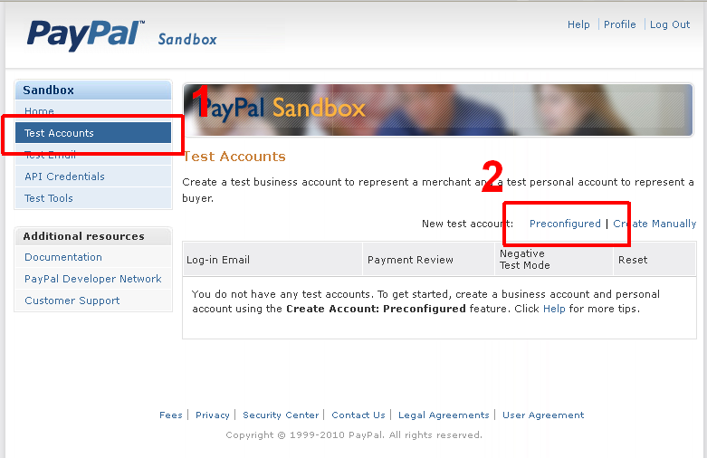

This will bring up the pre-configured account options.

For this guide we will be working with United States based accounts using USD as the currency.

For testing purposes we will make sure that all accounts are verified. They will have a credit card, a bank account and plenty of balance for testing purposes.

The API caller and Receiver will be set as “Seller” account type, and the Sender will be set as a “Buyer” account type. Please refer to the following images for all the parameters that need to be set.

***Tip*:**

*In this guide we are only creating accounts that are fully qualified (They have a Credit Card, a verified bank account and PayPal Balance) in order to make getting started easier. However, when you go live, you will encounter many variations in how accounts are set up.*

*Once your first basic implementation is up and running, we highly recommend that you test your application under a number of different scenarios. Appendix A presents the recommended scenarios that should be tested to insure a robust application that can handle common real life cases.*

Test Account 1: This account represents the API caller.

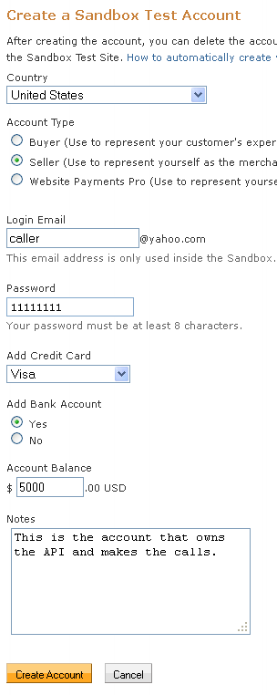

***Tip*:**

*Use the same password for all the test accounts.*

*This will simplify testing in later stages.*

Repeat the steps above and create an additional two accounts with the following configuration. These will represent the sender and receiver in the transaction.

|  |  |
| --- | --- |
| **Receiver** | **Sender** |
| C:\Documents and Settings\lmarkus\My Documents\resources\Getting Started\Preconfigured-2.png | C:\Documents and Settings\lmarkus\My Documents\resources\Getting Started\Preconfigured-3.png |

Once you are done, you should have three accounts set up (Virtual account emails will differ slightly from the sample image)

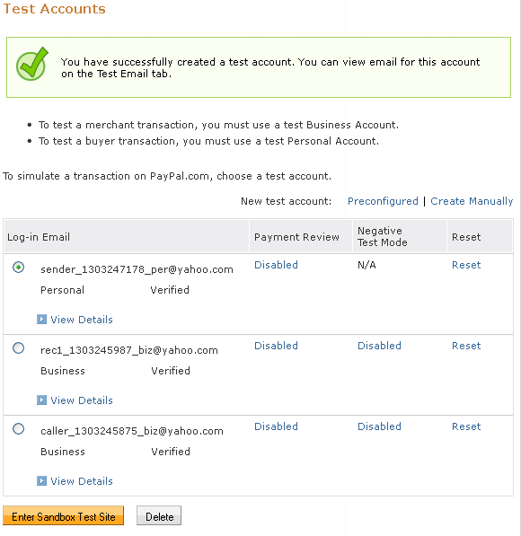

Obtaining API credentials for testing.

The following step is gathering the credentials you will need to make API calls in the sandbox. The first of these credentials is the APP-ID. All applications in the sandbox will use the following APP-ID: **APP-80W284485P519543T**

Like other sandbox credentials, this application ID works only within the sandbox. Once you are ready to move your application to a live environment, you will need to apply for your own App-Id (This is explained in more detail in chapter XX).

Next, we need to obtain the credentials for the account that will be making the API calls. This is the “Caller” account that we created in the previous step. The credentials needed are:

* *API Username* (This is different from the login email)
* *API Password*
* *Signature*.

To obtain these credentials go to the “API Credentials” menu, and take note of the ones for the caller’s test account. These will be used in our sample application.

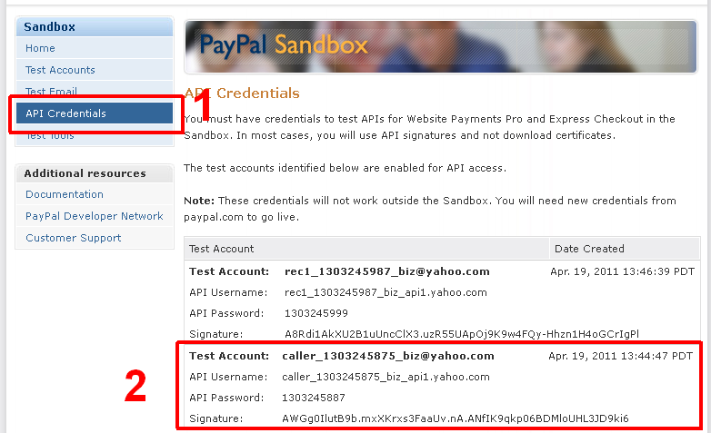

**An Adaptive Payments Primer**

**Our testing environment is fully set up. We are now almost ready to start coding, but first, we will take a quick look at how an Adaptive Payments program is typically implemented, and how the technology works.**

**An Adaptive Payments API call is nothing more than an HTTP request. The request needs to have a few PayPal-specific headers that will identify the caller, as well as the format of the information contained. The body of the requests contains all the pertinent information to the transaction (e.g.: Who the receivers are, what amount is being transferred, etc).**

**Here is an example of the simplest Pay request, presented in NVP (Name-Value pair) format:**

**Request Headers:**

|  |  |
| --- | --- |
| **X-PAYPAL-APPLICATION-ID** | **APP-80W284485P519543T** |
| **X-PAYPAL-SECURITY-USERID** | caller_1303245875_biz_api1.yahoo.com |
| **X-PAYPAL-SECURITY-PASSWORD** | 1303245887 |
| **X-PAYPAL-SECURITY-SIGNATURE** | AWGg0IlutB9b.mxXKrxs3FaaUv.nA.ANfIK9qkp06BDMloUHL3JD9ki6 |
| **X-PAYPAL-REQUEST-DATA-FORMAT** | NV |
| **X-PAYPAL-RESPONSE-DATA-FORMAT** | NV |

**\*(Credentials here are obtained in the previous step)**

**Request Body: *(Body formatted for readability. Actual request should not have unnecessary white space and parameter values should be URLencoded)**

actionType=PAY &

currencyCode=USD &

receiverList.receiver(0).email=rec1_1303245987_biz@yahoo.com &

receiverList.receiver(0).amount=10.00 &

returnUrl=http://www.example.com/success.html &

cancelUrl=http://www.example.com/failure.html &

requestEnvelope.errorLanguage=en_US

Let’s break down that call into a line by line explanation.

The first four request headers identify *who* the caller is to PayPal. The last two indicate the format that the body of the request is in, and how PayPal should format the response. In this example we are using NV (Name-Value pair) format, which is nothing more than *param1=val1 & param2=val3 &…&paramN=valN.*

The parameters used in this call are the minimum required by PayPal. They are:

**“actionType”**

This parameter lets PayPal know want you want to do with this call. In this case the value “*PAY*” indicates, as its name implies, a payment.

**“currencyCode”**

This parameter indicates what currency this transaction will be performed in. For this guide we will be using U.S. Dollars (USD).

**“receiverList.receiver(0).email”**

This parameter indicates who will be receiving the funds. This email address corresponds to that of the virtual account receiver previously created.

**“receiverList.receiver(0).amount”**

This parameter indicates the amount being sent to the recipient. This amount should always have exactly two decimal places.

**“requestEnvelope.errorLanguage”**

Tells PayPal in what language to present the results of this operation.

**“returnUrl”**

Tells PayPal where to redirect the user after he has approved the payment.

**“cancelUrl”**

Tells PayPal where to redirect the user if the transaction is not completed.

Now that we have our request, we need to send it to PayPal. The endpoint that handles *Pay* calls is:

https://svcs.sandbox.paypal.com/AdaptivePayments/Pay

Note the bolded Sandbox keyword. This means that this call will be sent to the testing environment. Once your application is ready for production, this must be removed from the Endpoint URL.

If everything goes well we will receive a response from PayPal very similar to the following:

paymentExecStatus=CREATED &

payKey=AP-11C14830PD187845M &

responseEnvelope.timestamp=2011-04-20T15:30:45.337-07:00 &

responseEnvelope.correlationId=0ca5aa73b42d5 &

responseEnvelope.ack=Success &

responseEnvelope.build=1846084

In this response there are three important parameters that one should look for.

**“responseEnvelope.ack”**

This is the result of the call. It will be either “*Success*” or “*Failure*”

**“payKey”**

This is a unique identifier for this transaction. You will use this identifier whenever you need to reference the transaction.

**“paymentExecStatus”**

Tells you if the payment has been completed or not. In this case we received a status of *CREATED*. This means that the payment has not been completed, and further action must be taken.

**This particular response tells us that the call was successful, and PayPal is now waiting for the sender of the money to approve the transaction.**

**This means that the sender must now be redirected to PayPal, so that he can review the details of the transaction, select the funding source, and click on “Pay”.**

**Once this happens, the funds will be transferred to the receiver, and the transaction will be completed. At this point, the user will be redirected to the website that was specified in the returnUrl parameter in the original call.**

**To redirect the user to PayPal, while referencing the transaction that he must complete, simply send the user to the following URL:**

**https://www.sandbox.paypal.com/webscr?cmd=_ap-payment&paykey=AP-11C14830PD187845M**

**Note the use of the sandbox keyword and also the use of the PayKey parameter.**

**Here, we will login and pay using the credentials for the “Sender” account we created:**

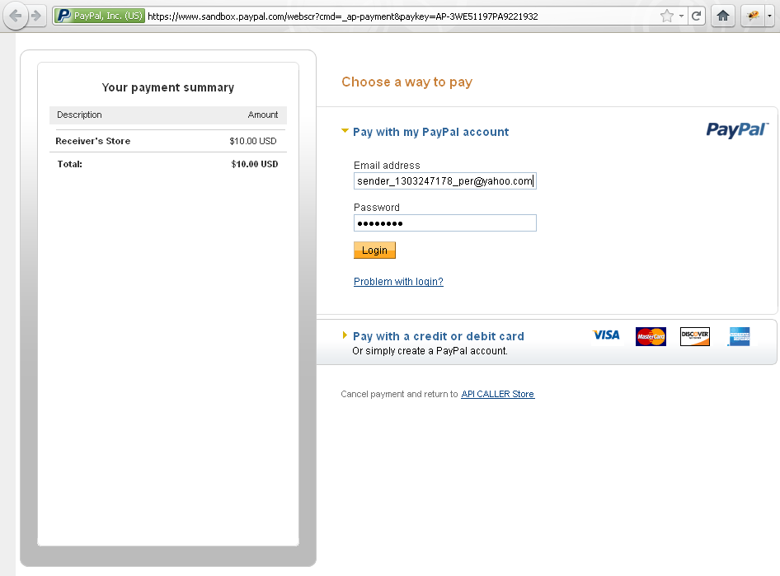

**Once this payment has been completed, PayPal will redirect the user to the URL specified in the API call. The transaction is now complete!**

**So in a nutshell, the steps to perform an Adaptive Payments Pay call are:**

1. **Create request with all payment parameters**
2. **Send request to PayPal**
3. **Receive response, and extract PayKey Parameter**
4. **Redirect buyer to PayPal using PayKey as a reference**
5. **PayPal returns buyer to your site after payment is complete.**

**Now that we have a test environment and we know how an Adaptive Payments call works; it’s time to write some code.**

**This guide contains examples in PHP and JAVA.**

**The sample code will execute the same example transaction that is shown in this guide.**

**If all goes well you should see the following:**

***Tip*:**

*The correlationId and timestamp should always be saved.*

*This information will be required by PayPal support engineers should an issue arise.*

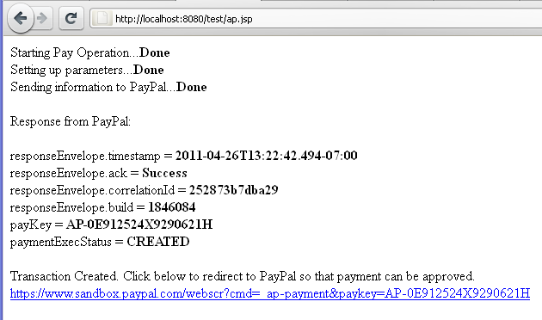

**Ideally, the user should be automatically redirected to PayPal, but we take this intermediate step so that the response from the API call can be studied.**

**The parameter responseEnvelope.ack will tell you if the transaction was accepted by PayPal**

**Parameters correlationId and build are log identifiers for this API call. This information should be saved as it will be useful in troubleshooting should any issue arise.**

**The payKey parameter is the transaction token that will be used to redirect the user to PayPal. This token should also be saved, as it becomes a permanent identifier for the transaction once the payment has been created; and will be necessary in a number of other calls related to the transaction (Such as getting transaction details, performing a refund, etc).**

**Finally the paymentExecStatus parameter shows you what the result of the payment request was. In this case, “CREATED” means that the payment is set up, but awaiting approval from the sender. This is why we must redirect the user to PayPal in order to complete the transaction.**

**Now that the transaction is completed, we will log into the sandbox as the receiver, so that we can verify our transaction. This login is done at:** [*http://www.sandbox.paypal.com*](http://www.sandbox.paypal.com)

**Note the credentials belong to the receiver test account that we created.**

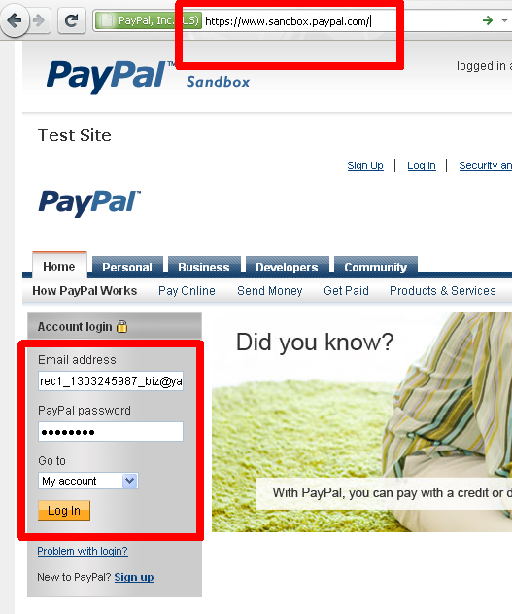

**Here we can see that the transaction was completed successfully and that the money has been received.**

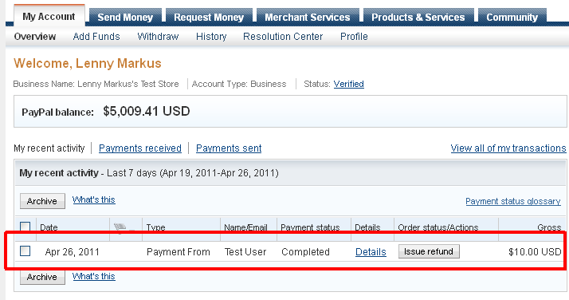

**Congratulations! You’ve made your first transaction using Adaptive Payments!**

**By now you should have a more complete picture of how the PayPal API system works, how to make calls and how the responses from PayPal are structured.**

**Keep in mind that this guide only highlights a very simple example of sending money from point A to point B. However, the Adaptive Payments Platform is much more powerful and flexible, and can allow you to implement some very complex business models.**

**With Adaptive Payments you can create applications that split up payments between many recipients, you can create payments that travel down a chain of recipients; you can create subscriptions based businesses using Pre-Approvals, and much more.**

**Now would be a good time to do some more reading on the Adaptive Payments developer’s guide, to get a taste of all that it offers. Documentation can be found here:**

[https://www.x.com/community/ppx/documentation#ap](https://www.x.com/community/ppx/documentation%23ap)

**So far we have only been working with virtual accounts. The next section shows you how to obtain live credentials, so that you can start using your application in a production environment, with actual users and of course, real money.**

****Going Live****

**Hopefully by now you have built a more complete application, and you are ready to launch your website.**

**At this point you will go from working with virtual accounts to real accounts, but there are a couple of steps that must be taken before this happens.**

**PayPal is a global leader in online payments and one of our main goals is offering a safe, secure and reliable environment for all out users. Before you are granted permissions to make Live API calls, you must submit your application for review by PayPal.**

**During the review process, two things will happen. First, a PayPal agent will use your application from a buyer’s point of view to ensure the correct flow and utilization of the API’s.**

**Second, your business model will be thoroughly evaluated to ensure the safety of our customers, as well as to verify compliance with all PayPal guidelines and terms of service.**

**The PayPal Developer agreement highlights all the key points that your application must comply with. This document can be found at the following link, and should be fully read and understood before submitting your application to PayPal for review.**

**[** <https://www.x.com/docs/DOC-2161> **]**

****Obtaining a live APP-ID****

**In order to submit your application for review, you must take the following steps:**

* **Log in to X.com using the PayPal.com account that will own the application and make the API calls. This account must be a Premier Verified or Business Verified account to be eligible for making API calls. If you are developing for a third party, make sure that the submission is performed under their name. Otherwise, ownership of the application may be necessary, causing delays.**
* **Go to the “My Apps” menu**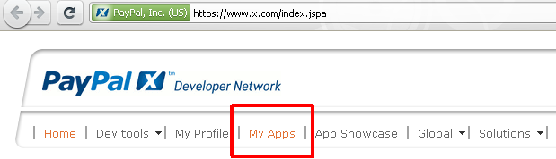
* **Click on “Submit New App”**

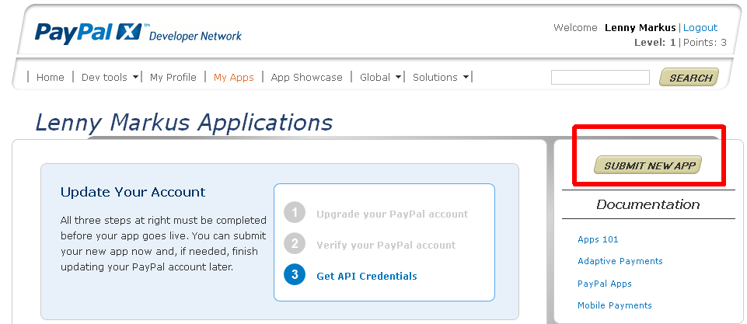

**At this point you will be presented with the submission form. This form should be filled out as completely as you can. The more information you present to the PayPal reviewers, the easier it will be for them to understand and approve your application.**

**Please note that the *“Will your app be embedded into PayPal.com”* option should be set to No.**

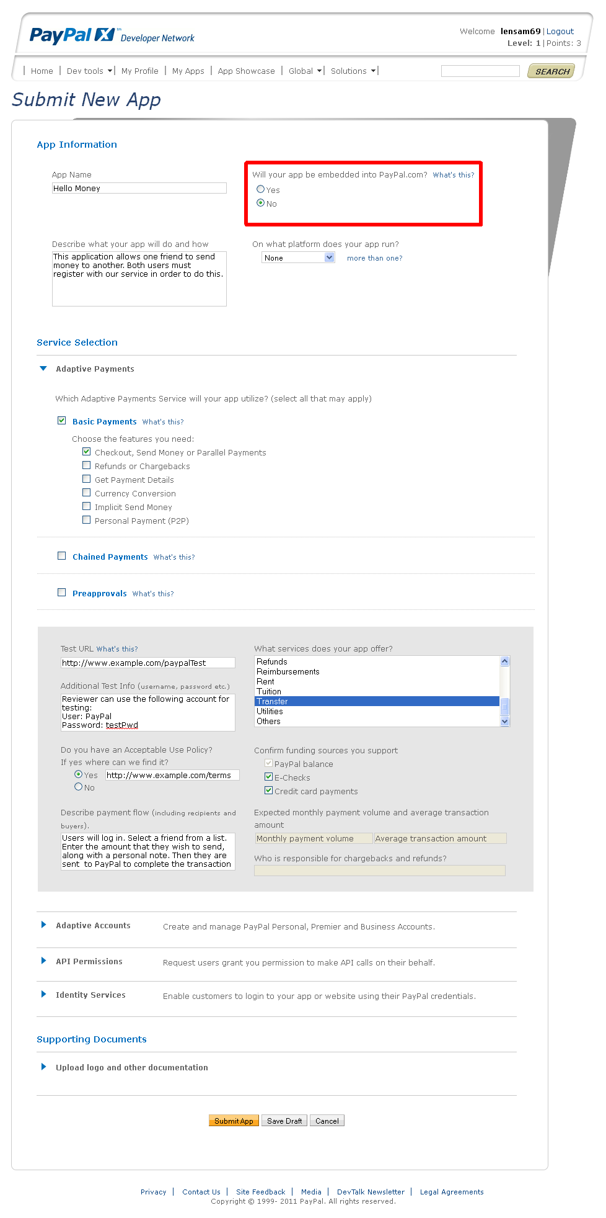

****What to expect now****

**Now that you have submitted your application, a PayPal agent will perform a full review.**

**Finally, reviewers might require additional information, or have questions about your app. If so, they will post questions on the app submission page on X.com, which can only be accessed by the same account that submitted the application.**

**Until the application is approved, it is a good idea to check back often, as the review process will be stopped until these questions / requests are answered by you. If any questions are posted, a notification will be sent to the email that was used to submit the application. If you don’t have access to this email, make sure to check back on X.com often. It is also a good idea to check your junk mail folder, to insure that legitimate PayPal messages are not being marked as spam.**

****How long will it take to approve my application?****

**All reviews are performed on a first-come, first-serve basis. There is no expedited process available. Review times can vary, and you should take this into account in your business planning.** The review time varies depending on a number of factors, including the APIs your app uses, the uniqueness and complexity of the business model, if you are submitting a PayPal App, or if you are applying for Business Payments. We might ask a lot of questions or just a few, it all depends.

## If you are using Standard APIs ONLY:

If your app uses Standard APIs like Send Payments or Parallel Payments, you can begin using the APP ID in a live environment as soon as you submit your application. PayPal will take a closer look at your app within 24 – 72 hours to ensure that your app meets all requirements for final approval. If there are any questions or concerns during this review period, you will be contacted. If you have not heard from us during or after this period, you can assume your app was reviewed without concern and you may continue using the live APP ID that was assigned to you.

## If you are using Advanced APIs:

If your app uses Advanced APIs like Chained Payments, Pre-approved Payments, Personal Payments, Create Account (Business), you are submitting a PayPal App, applying for Business Payments, or you have a complex business model, you can expect the review to take approximately 5 – 15 days. On occasion some reviews will take longer, however this is due to how quickly you respond to our questions or how complex your business model may be.

## Upgrades****:****

If you decide you would like to upgrade or add any Advanced APIs (Chained Payments, Pre-approved Payments, etc) to your already approved app, please contact Developer Technical Services at [www.paypal.com/dts](http://www.paypal.com/dts). Note that we may need to test the new payment model/flow and your app may be subject to the 5 – 15 day process for Advanced APIs.

# Things to consider

Implementing your solution and receiving a Live App-Id is only part of the bigger picture. You are now running a live website and are handling money, as well as dealing with people. PayPal focuses on protecting its customer's money, as well as ensuring their satisfaction and providing a high quality user experience. You should strive for the same goals in your website.

## Security

During the integration process, security is usually not a big concern, because the developer is acting as a trusted party; however, once your application is nearing completion; securing your checkout process should be a very high priority.

Particularly, when using pre-approvals, the burden of verifying that a user is who he claims to be is shifted to you, since PayPal will not request their login/password to complete a pre-approved transaction. We offer a document outlining our recommended information security guidelines, which is an excellent starting point towards securing your website. This document can be found at the following link:  [https://www.x.corn/cornmunity/ppx/apps101/info_security_guildlines](%20https:/www.x.corn/cornmunity/ppx/apps101/info_security_guildlines%20)

## Quality Of Service

Offering a high quality user experience is another piece of the big picture that you must complete. Transactions will not always go as planned, and you may find yourself in unexpected situations.

You should be prepared to deal with customers who may be unhappy with their product / service, and request refunds, or initiate disputes. Having a clear Terms-of-Use policy, as well as a Returns policy readily available on your website is a very good way of protecting yourself, and it lends credibility to your business.

If you have a business with a high volume of transactions, you might benefit from integrating refunding functionality into your application. Besides the Pay API, PayPal also offers a number of API's that enable you to obtain transaction details, status issue refund's etc.

You should consider leveraging the full range of PayPal's API's in order to automate a large part of the accounts receivable aspect of your business. Using a tried and tested solutions from PayPal will provide you with a robust base on which to build your business, while at the same time allowing you to direct your time and energy to other areas.

## Branding

The PayPal brand is globally trusted by millions of users, and by integrating it in your checkout process, you can take advantage of this. Making proper use of the PayPal brand during your checkout process enhances trust, and gives credibility to your site.

For proper use of PayPal logos and assets, please read the following document: [https://www.x.com/docs/DOC-1506](https://www.x.com/docs/DOC-1506%20) . It outlines correct usage of PayPal logos and buttons in a way that is consistent with brand guidelines. This is important as it makes your website look legitimate.

****Appendix A – Naming Conventions****

In this guide we only created three accounts for testing purposes. To keep things simple we named them *caller, sender* and *rec1*. As you start creating more virtual accounts for testing purposes, it’s important to keep a uniform naming convention to avoid clutter and streamline testing. You should be able to know exactly what an account represents just by looking at its name.

The sandbox only allows you to customize the first six characters of an account, so you need to maximize the information in them.

The following is an example of how to standardize your names:

* There are two categories of user accounts: **(P)**ersonal and **(B)**usiness.
* An account can be **(V)**erified if it has a BankAccount or **(U)**nverified if it does not.
* Finally, an account can have a **(C)**redit card associated to it or not.
* Use the remaining space for assigning a number to the account

Using these letters we can have the following naming convention for accounts:

|  |  |  |  |  |
| --- | --- | --- | --- | --- |
| Account Name | Personal | Business | Verified | Credit Card |
| PVC | ✔ |  | ✔ | ✔ |
| PV | ✔ |  | ✔ |  |
| PC | ✔ |  |  | ✔ |
| P | ✔ |  |  |  |
| BVC |  | ✔ | ✔ | ✔ |
| BV |  | ✔ | ✔ |  |
| BC |  | ✔ |  | ✔ |

So, at a glance , we can tell that the following account: **BV1_ 1296593066_biz@gmail.com** is a Business Verified account that does not have a credit card. **PC3_ 1296672107_per@gmail.com** is a Personal non-verified account, that only has a Credit card as a funding source.

This scheme is an example. Feel free to use one that works for you; that will help you keep a large number of accounts organized, and easily recognizable at a glance.

****Appendix B – Further Reading****